Year 7 Science Project

Name ________________________

Weighting: 40%

Task 4: Project video

Total: /36

**Design a device which will allow us to increase the drinkability of the water**

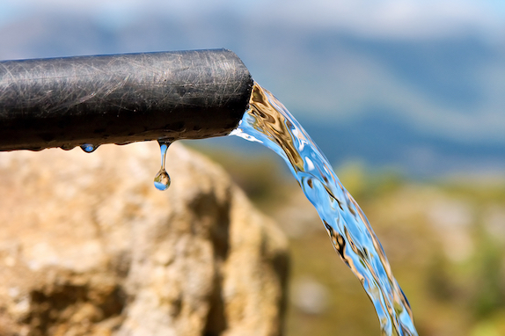

Your group will be creating a method to improve the drinkability of contaminated water in remote communities in Western Australia. Your task it to create a video (maximum 5 minutes) that shows the process of planning, creating, and implementing the method. In your video, consider the following:

* Ensure all participants in your group have an equal role
* All engineers plan first! Show this in your video
* Your method will be designed using equipment available in the science laboratory
* Discuss any changes or improvements you need to make. Explain why you needed to make the changes.
* Your final method should be described in the video. Explain to the viewer how it works using scientific vocabulary.
* Explain how your method could be completed in the real scenario so that people in the remote community can improve the drinkability of their water using everyday items.

You will have six lessons to research, plan, test, and review your method AND create your video. It is recommended that you take short videos throughout your process and save the final lesson for combining and editing.

**WORKING IN A GROUP**

Remember working as a team means multiple tasks can be completed at once. If you find yourself without something to do in class, discuss with your group and go through the list below to see if you have done the following.

* Research how to remove impurities from water
* Draw a plan and explain why you have designed it that way – how will it work?
* Write up a list of equipment you will need from the prep room
* Consider what safety steps you will have to take
* Collect equipment from the trolley
* Take photos and videos of the method
* Clean up and tidy the area
* Consider how your method could be completed in the real scenario
* Compile and edit videos



Keep a track of what you complete each lesson below.

Day 1 – _____________________________________________________________________

___________________________________________________________________________

Day 2 – _____________________________________________________________________

___________________________________________________________________________

Day 3 – _____________________________________________________________________

___________________________________________________________________________

Day 4 – _____________________________________________________________________

___________________________________________________________________________

Day 5 – _____________________________________________________________________

___________________________________________________________________________

Day 6 – _____________________________________________________________________

___________________________________________________________________________

Marking Key

|  |  |  |  |
| --- | --- | --- | --- |
| **Criteria** | **3** | **2** | **1** |
| **Group work**  ● Ability to work together  ● Assigning tasks within the group | Evidence of distribution of roles | Some evidence of a distribution of roles | Appears that a number of individuals worked on a task |
| A shared vision with an equal distribution of tasks | Relies on one person to lead the group, allocate roles etc | Members of the group working individually. |
| **Design**  ● Design and test a method.  ● Revision and improvement of design  ● Application to real world | Method has been carefully put together using ideas from research. | Method has some issues in design, not a lot of research into the design. | No evidence of research and a careless method created. |
| Evaluates and revises ideas, and can explain the reasons behind changes. | Evaluates and revises ideas but does not provide the reason behind the changes. | Limited evaluation of revision of ideas, method or solutions. |
| Accurate consideration and application to the context has been applied. | Consideration and application to the context has been applied. | There has been some consideration of the context. . |
| **Time management** | Time used effectively | Some evidence of time pressure. | Task is rushed, incomplete. |
| **Presentation**  ● Quality of presentation  ● Explanation of ideas  ● Team participation | Video is of high quality, very easily understood. | Video is good, some areas that could be improved. | Most areas of video could be improved |
| Presents all of the information and findings, along with supporting evidence in a logical manner. | Presents some of the information and findings, but lacks supporting evidence and no logical flow of presentation. | Struggles to present information and findings in a concise, logical manner. Little to no linear progress. |
| All team members participate equally. | All team members participate, but not equally. | Not all team members participate. |
| **Science ideas**  ● Separation techniques  ● Purify water  ● Vocabulary | Shows a very clear understanding of techniques needed to filter water. | Shows some understanding of techniques needed to filter water. | Water is cleaner than it started but no explanation of techniques used. |
| Water is clean and clear. | Water is clear. | Water is neither clear or clean. |
| Chemistry vocabulary is used correctly at every opportunity | Some chemistry vocabulary is used correctly | Minimal chemistry vocabulary is used correctly |